Volunteer Application to be a Signature Gatherer in 2023-2024

Instructions: Please fill out each question to the best of your ability.
Estimated Completion Time: 10 minutes

Have questions? Email us: info@educationfreedomfororegon.com
Website: www.educationfreedomfororegon.com

Thank you for signing up to be a consistent volunteer for our historic School Choice and Open Enrollment movement!

By signing up to be a volunteer, you agree to check your email and texts daily.
* Required

1. First Name*

2. Last Name*

3. Address (Street, city, zip code)*

4. County*

5. Email*

6.Phone (for text communications)*

Continued on Next Page…

7. Do you have kids enrolled in Oregon K-12? Circle or Highlight all that apply.

Yes, private school

Yes, public and charter school

Yes, homeschool

I have no kids in the Oregon education system

8. Emergency Contact (Name, Address, and Phone)*

9. To help us put a face to your name, please print and attach to your application a Portrait Photo of Your Face and mail both in the same envelope.

10. Referred By (how did you hear about our School Choice movement?)

Part 2: Schedule and Availability

1. Who can sub for you in case you are sick? (Provide Name and Phone of person who will sub for you)*

2. How many hours per day will you be available to volunteer?*
Circle One Option

1-3 hours

4-6 hours

more than 6 hours per day

3. Days of the week you are available to volunteer* Circle or highlight all that apply.

Monday

Tuesday

Wednesday

Thursday

Friday

Saturday

Sunday

4. Would you like to volunteer in any of these locations:* Circle or highlight all that apply.

Public Sidewalk

In front of a store (front sidewalk)

Fairs and Trade Shows

Door to Door Knocking

Organized Events and Rallies

I have no preference where I volunteer

I would only like to volunteer from within my home (phone calls, emails, digital work)

5. I am usually available on short notice.* Circle One Option.

Yes

No

Continued on Next Page….

6. Do you have the following items for signature gathering: *

1. water proof bag or plastic container to hold completed petitions
2. water bottle
3. good walking shoes
4. hat and sunscreen (during summer)
5. clipboard
6. pens
7. folding chair
8. folding table
9. hand sanitizer

Circle One Option Below:

I have read the list of needed items and confirm I have all of these items.

I have read the list of needed items but I am missing a few items. I confirm I will get all these items before I begin collecting. signatures

Part 3: Important Documents

Please Read:

Notes To Person Collecting Petition Signatures

The person collecting petition signatures (the “Circulator”) needs to ask the prospective signer if he/she is a registered Oregon voter. It is crucial that the signer is a registered Oregon voter.
1. If the signer is unsure if he is registered or unsure how he signed his name or what address he used, we cannot accept the person’s signature. Please ask the signer to come back after he has confirmed his information.
2. If the signer is unable to sign himself and wants to have an agent with a power of attorney sign, we cannot accept the agent’s signature at this time. As a result, we will not be able to accept that signature on our petitions.
3. The signer needs to carefully give his signature in the first spot of a line on the 10 liner form—as close as possible to how he signed when he registered to vote.
4. The signer needs to write in the date he is signing.

5. The Circulator needs to confirm that the date written in is the correct date and not out of order with the date from previous signatures on the 10 line form.
6. The signer needs to carefully print out his name and address where he is registered to vote. The signer’s printed name and address are used by the Secretary of State to find his records and confirm his signature.

7. It is best if the signer NOT use “ditto” or “same” when a husband & wife are signing. It is better for each signer to fully write out his own info on his line.
8. The signer does not need to write in Oregon because the petition is for Oregon.
9. If the signer makes a mistake, he should cross out the mistake, write in the correct info and initial it. If the mistake is big enough, he should use one long pen line to cross out the whole line, initial it and start on the next line.
10. The Circulator needs to watch the signer sign the petition.
11. After the petition page is full or the Circulator is done collecting signatures for that page the Circulator must sign and date the page. The date that the Circulator writes in MUST be on or after the date of the last signer. The Circulator must write out all of his information at the bottom of the page. The Circulator cannot use return address labels.
12. NO ONE should fill in the page number in the lower right corner—we will do that AT THE END.
13. It is not a big deal if a signer writes out of the lines a bit.
14. The Circulator must make sure that the back side of the 10 liner form has printed on it the text from the Secretary of State’s office. We will supply the 10 liner form and the Secretary of State text that goes on the back side of the 10 liner form.

15. The Circulator MUST have copies of the two School Choice Amendments at the signing location and available for the signer to read if the signer wants to.

16. The Circulator should keep all completed pages safe in a water-proof container and locked in his car.
17. The Circulator should not hole punch the 10 liner form.
18. The Circulator should not argue with a signer. Safety First!

Continued on Next Page…
Please read the following 4 pages of Oregon SOS Rules for Signature Gathering: *

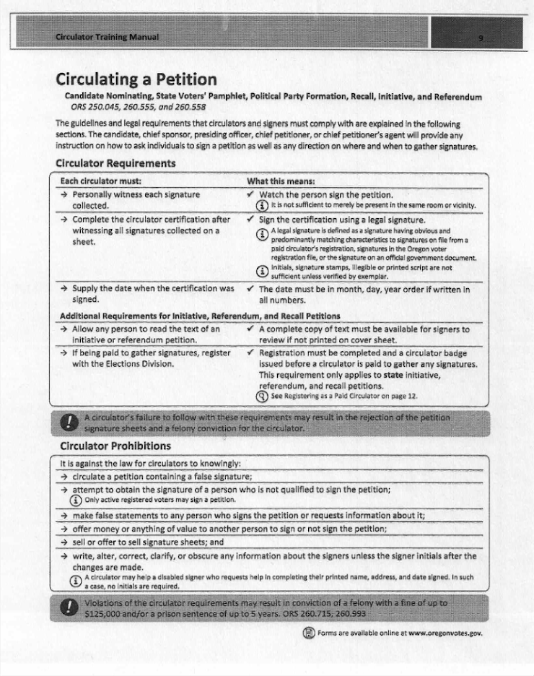
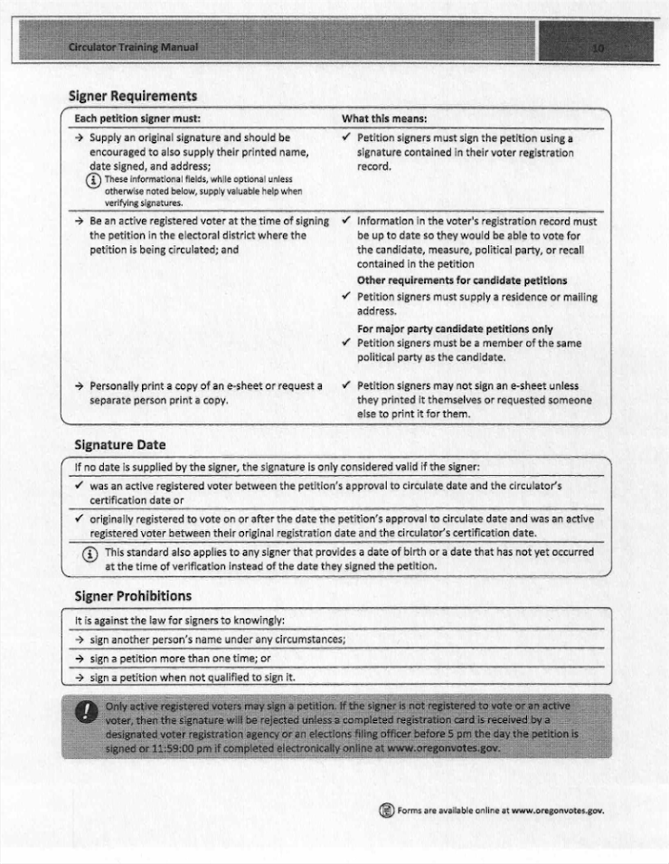
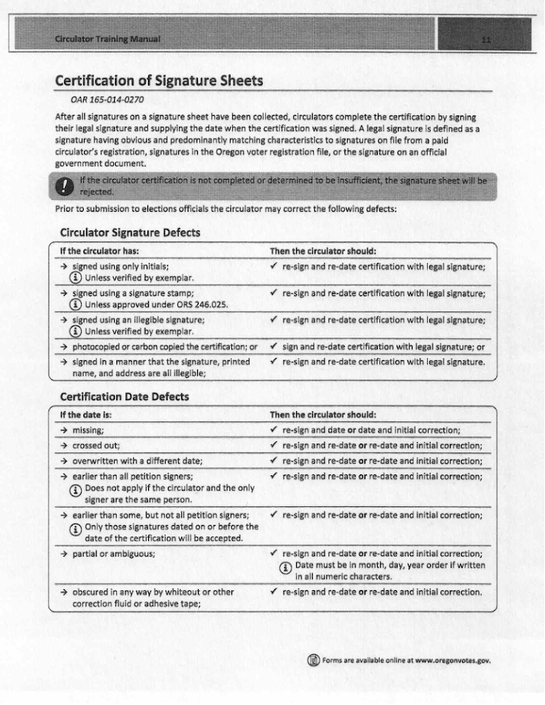
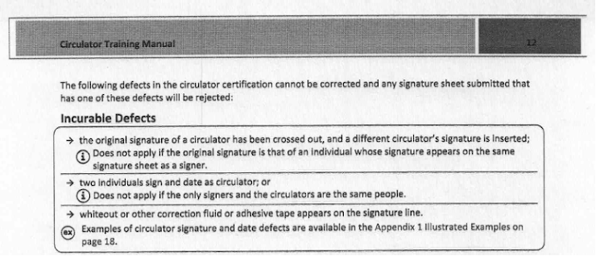

By my signature, I verify that I have read and understand the information in this volunteer application.

Please sign your full name below:*

Please mail this application back to Education Freedom for Oregon at PO BOX 3242, TUALATIN OR 97062-3242.

